***The Harbor Ridge Homeowner***

**A Publication of the Harbor Ridge Homeowners Association Summer 2015**

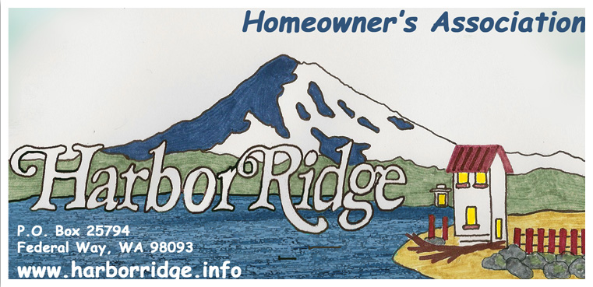

Summer is here and the growing season is in full swing. Please heed our annual call to trim shrubs, trees, and other tall growing vegetation from sidewalks, especially near corners and intersections. Some landscaping causes the dreaded “Blind Intersection”. Those intersections are traffic hazards but more importantly, block a driver’s view of kids on bicycles, skateboards or simply stepping off the curb to cross the street.

Most of us will spend time away from our homes during the summer. Leaving our property unattended is becoming worrisome. Burglaries and car prowling is increasing in our community. Please be suspicious of unusual activities or strange vehicles on our streets. If something seems a little “off” take a photo. It can always be deleted, but it might help your neighbors recover prized golf clubs removed from their vehicle or heirloom jewelry burgled from their house.

**COVENANTS, CONDITIONS AND RESTRICTIONS (CC&R’s):** check out this summer

CC&R Articles III, Section 2 and Article IV, Section 7 and 18:

Article III, Section 2. The following actions shall also require the prior written approval of the ACC:

* Changing the grade or natural drainage of any lot
* Planting any tree or shrub which is or may grow to be greater than 15 feet in height
* Cutting or removal of any tree greater than 4" in diameter at a height three feet above the ground

Article IV, Section 7. All lots, whether improved or not, shall be fully maintained, including the control of any vegetation.

Section 18. Except with the approval of the ACC, no owner shall at any time keep or allow to be kept on their premises any commercial vehicle, house trailer, truck, camper, mobile home or boat trailer unless housed within a garage or suitably screen from view from any street or lot. For purposes of this provision, a vehicle will be deemed to be stored or kept if parked in driveways or streets for a period of longer than twenty-four (24) hours in any seventy-two (72) hour period.

Several CC&R violations were cleared and your board and neighbors thank each and every homeowner who voluntarily returned their properties to CC&R specifications. Several glaring and continuing CC&R violations stubbornly remain unresolved.

The board may become directly involved in settling CC&R violations once a homeowner initiates a complaint. Homeowners are responsible for starting the process to remedy violations. One avenue available to homeowners is the pursuit of compliance with Tacoma Municipal Codes. The most direct way to determine if a Tacoma City code violation exists is by contacting “Tacoma First 311”. They are located at: 747 Market Street, 2d floor, Tacoma, WA 98402. They may be contacted at: 253 591-5000 or through their web site. The easiest way to navigate the internet to their site is by searching for Tacoma First 311.

**GARBAGE, GREENS AND RECYCLING:** Please ensure trash and yard waste containers are stored out-of-sight and are placed at the curb close to our normal Tuesday pick up schedule.

**“BE GREEN” OPTION:** Members are encouraged to receive periodic Newsletters by email instead of normal postal delivery. Several members take advantage of this option and we would love to increase that number. To sign up for email delivery, please visit our website at: [www.harborridge.info/](http://www.harborridge.info/) contacting the board with your email address request.

**WEBSITE:** Please visit our website at [www.harborridge.info/](http://www.harborridge.info/). What will you find there? The Harbor Ridge By-Laws, Covenants, Conditions and Restrictions (CC&R’s), board members names and phone numbers, the Board’s meeting dates and much more.

**NEIGHBORHOOD AWARENESS:** At varying times, there are homes in our area that are vacated, for sale, or in foreclosure. Please be particularly aware of homes that are vacated, both for your sake as a neighbor, and in the interest of the owner. If you notice anything unusual, please report it to the owner, and possibly to the police.

Both in Northeast Tacoma and in Federal Way, unauthorized individuals have occupied vacated homes. If you have questions about any police issue, please direct them specifically to the police department’s Community Liaison Officer (CLO) for our area Officer Brandon Showalter at 253-594-7951 or Brandon.showalter@cityoftacoma.org.

## A WELCOME TO OUR NEW BOARD MEMBER!!!!

We welcome our newest board member --- Wayne Rhodes. We appreciate this neighbor volunteering for an opening on our Harbor Ridge Homeowner’s Association. For information on who all of the board members are, visit our website at: http://[www.harborridge.info](mailto:cathbix@yahoo.com).

**HARBOR RIDGE MAP WITH HOMEOWNERS WHO PAID ON 2015**: Our summer newsletter includes a Harbor Ridge map highlighting those homeowners who paid their dues on 2015. We are very grateful to those who regularly show their commitment to the community by contributing to the association. Your home owners association has undertaken several significant capital improvements. We want to continue making enhancements to our Harbor Ridge plat by investing in areas of interest to all of us, and maintaining them on a regular basis. Your annual thirty-five dollar dues are the sole revenue source that allows us to undertake these projects.